State Machine Time Measurement

Read State Machine:

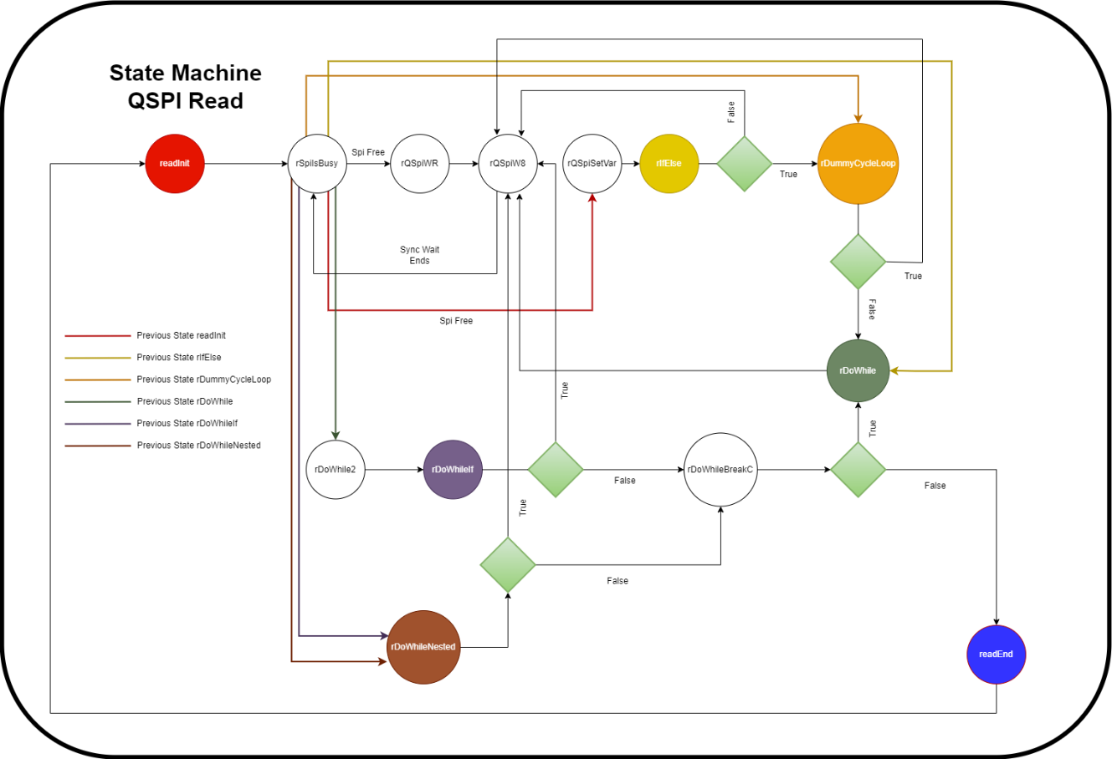

State | Max. Time Taken | Extra Info
readInit | 2.08us
rSpiIsBusy | 1.88us
rQSpiWR | 5.88us | calling spiWriteRead
rQSpiW8 | 1.64us
rQSpiSetVar | 1.84us
rIfElse | 1.5us
rDummyCycleLoop | 4.24us | calling spiRead
rDoWhile | 4us | calling spiWriteRead
rDoWhile2 | 710ns
rDoWhileIf | 1.6us
rDoWhileNested | 4.2us | calling spiRead
rDoWhileBreakC | 1.7us
readEnd | 1.7us

Write State Machine:

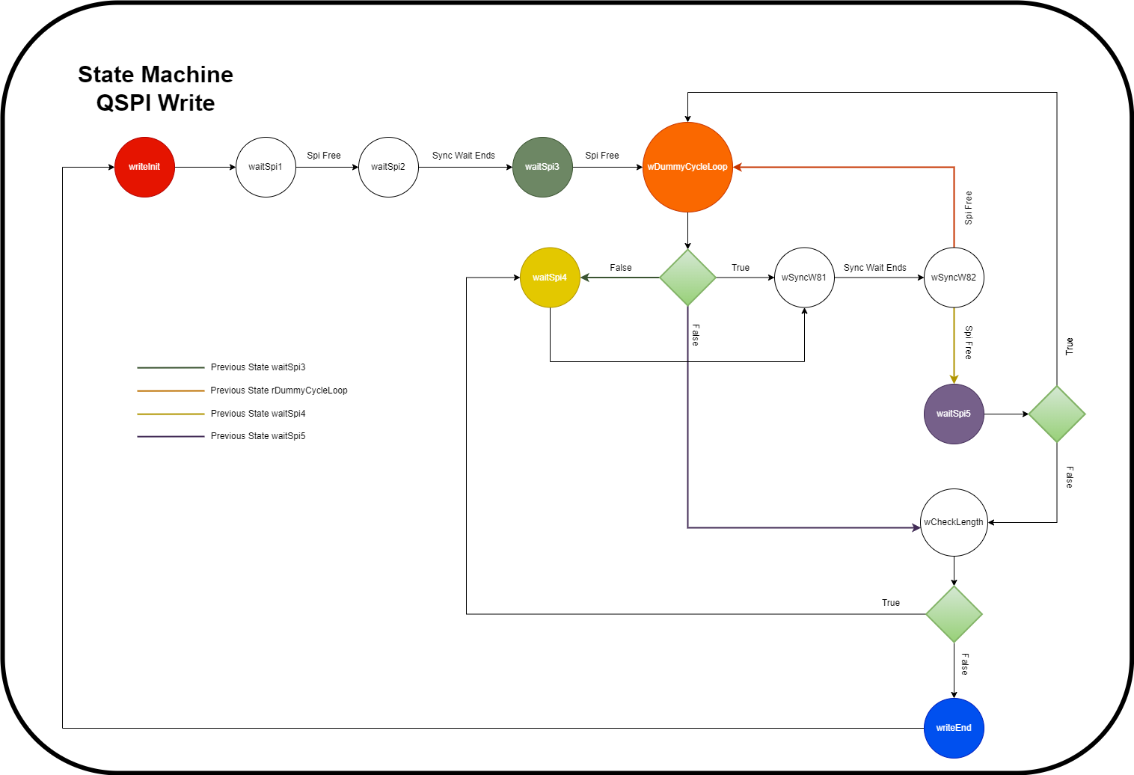

State | Max. Time Taken | Extra Info
writeInit | 1.52us
waitSpi1 | 5.44us | calling spiWriteRead
waitSpi2 | 1.13us
waitSpi3 | 1.76us
wDummyCycleLoop | 3.6us | calling spiRead
wSyncW81 | 1.17us
wSyncW82 | 1.37us
waitSpi4 | 3.4us | calling spiWrite
waitSpi5 | 1.17us
wCheckLength | 1.14us
writeEnd | 1.18us

